Day-12 Task-3: Schema design and querying on E-commerce dataset (Day-11 Task-3 dataset)
- Database creation
CREATE DATABASE DB_DAY_12_TASK_3;
USE DB_DAY_12_TASK_3;

- Schema creation (table)

CREATE TABLE CustomerOrders(
order_id VARCHAR(16) PRIMARY KEY,
order_datetime TIMESTAMP NOT NULL,
customer_id VARCHAR(16) NOT NULL,
city VARCHAR(32),
product_name VARCHAR(64) NOT NULL,
category VARCHAR(32),
cost_per_unit DECIMAL NOT NULL CHECK (cost_per_unit > 0),
quantity INTEGER NOT NULL CHECK (quantity >= 0),
payment_method VARCHAR(24),
revenue DECIMAL NOT NULL CHECK (revenue >= 0)
);

- Data Insertion

INSERT INTO CustomerOrders VALUES ('ORD-1001', '2024-01-03 09:15:36', 'CUST-501', 'Chicago', 'Wireless Ergonomic Mouse', 'Electronics', 29.99, 2, 'Credit Card', 59.98);
INSERT INTO CustomerOrders VALUES ('ORD-1002', '2024-01-03 10:42:15', 'CUST-502', 'Seattle', 'Mechanical Keyboard', 'Electronics', 89.5, 1, 'PayPal', 89.5);
INSERT INTO CustomerOrders VALUES ('ORD-1003', '2024-01-03 12:05:27', 'CUST-503', 'Austin', 'Organic Green Tea (Pack of 50)', 'Grocery', 14.25, 3, 'Debit Card', 42.75);
INSERT INTO CustomerOrders VALUES ('ORD-1004', '2024-01-03 08:30:43', 'CUST-504', 'Denver', 'Yoga Mat Non-Slip', 'Fitness', 24, 1, 'Credit Card', 24);
INSERT INTO CustomerOrders VALUES ('ORD-1005', '2024-01-03 14:22:09', 'CUST-505', 'Boston', 'Ceramic Coffee Mug 12oz', 'Home & Kitchen', 12.5, 4, 'Apple Pay', 50);
INSERT INTO CustomerOrders VALUES ('ORD-1006', '2024-01-03 11:10:54', 'CUST-506', 'San Francisco', 'Noise Cancelling Headphones', 'Electronics', 199.99, 1, 'Credit Card', 199.99);

- Grouping, Sorting and applying aggregate function
Display total revenue of each category of products in descending order

SELECT category, SUM(revenue) AS total_revenue FROM CustomerOrders GROUP BY category ORDER BY total_revenue DESC;

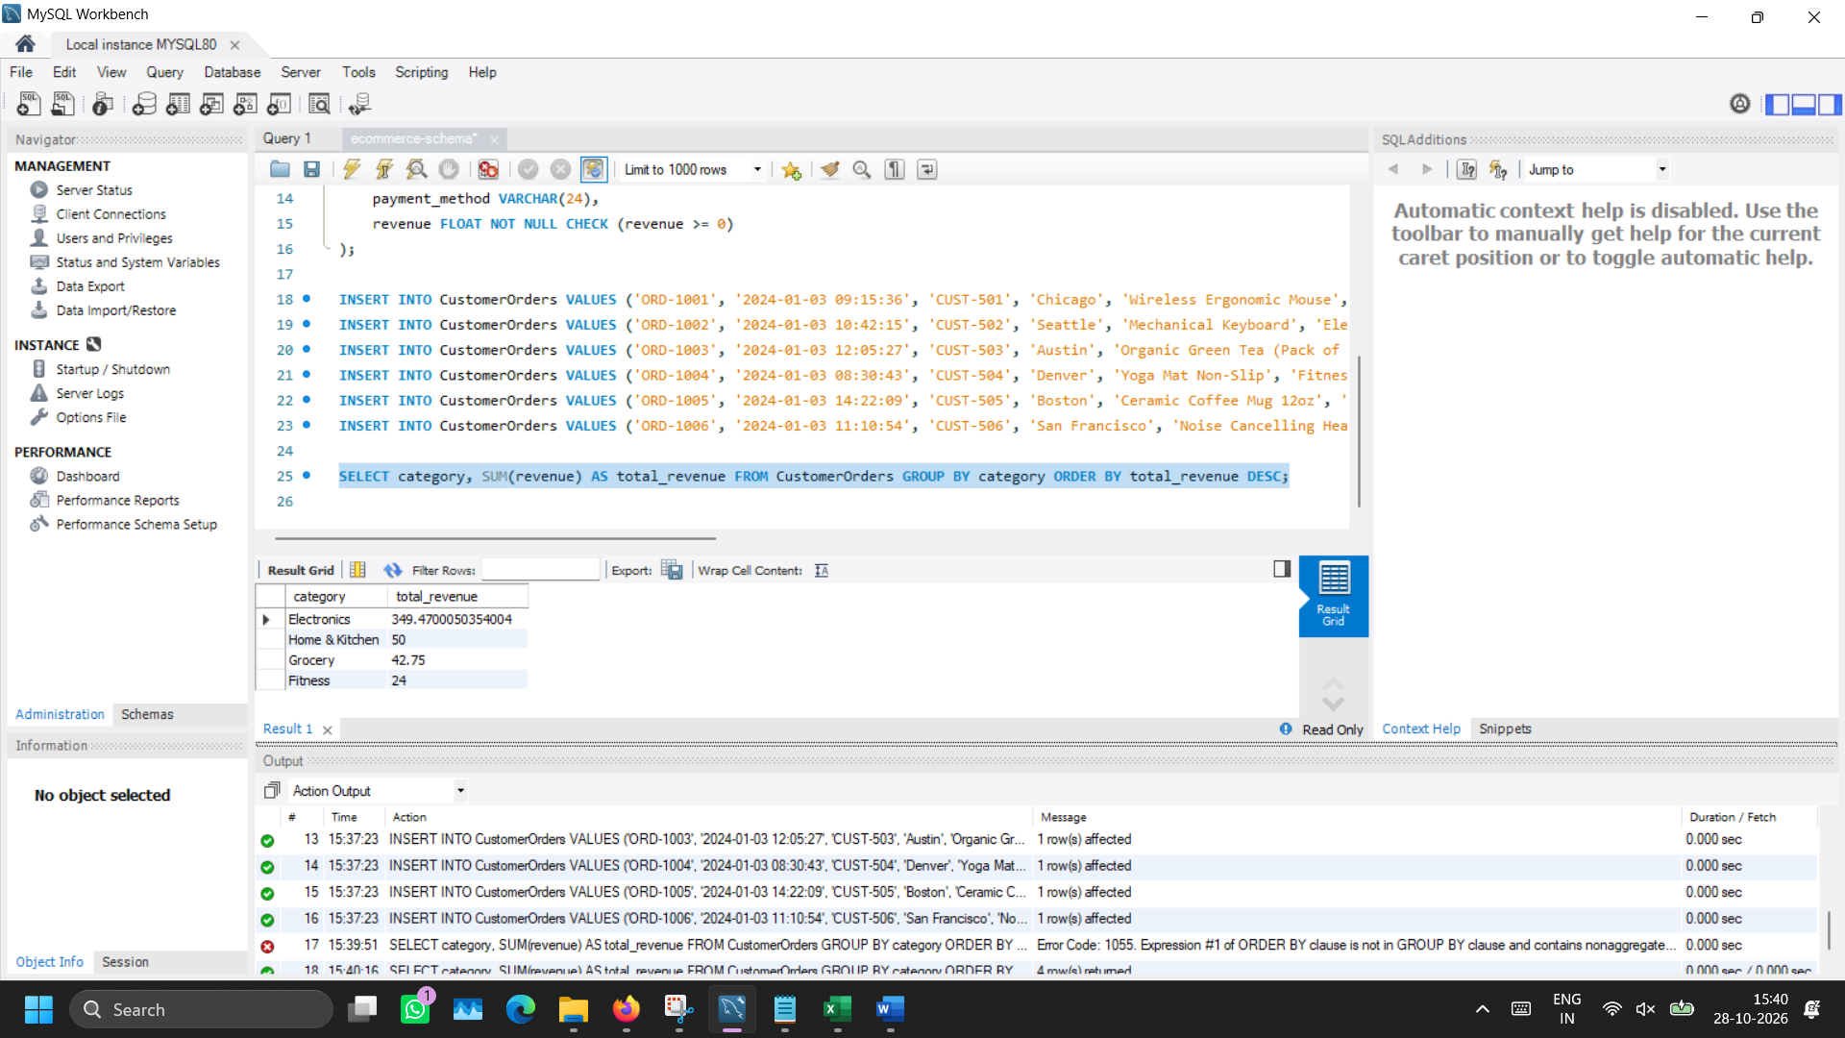

- WHERE clause usage
Retrieve orders info which was made before noon of January 03, 2024

SELECT order_id, order_datetime, customer_id FROM CustomerOrders WHERE order_datetime < '2024-01-03 12:00:00';

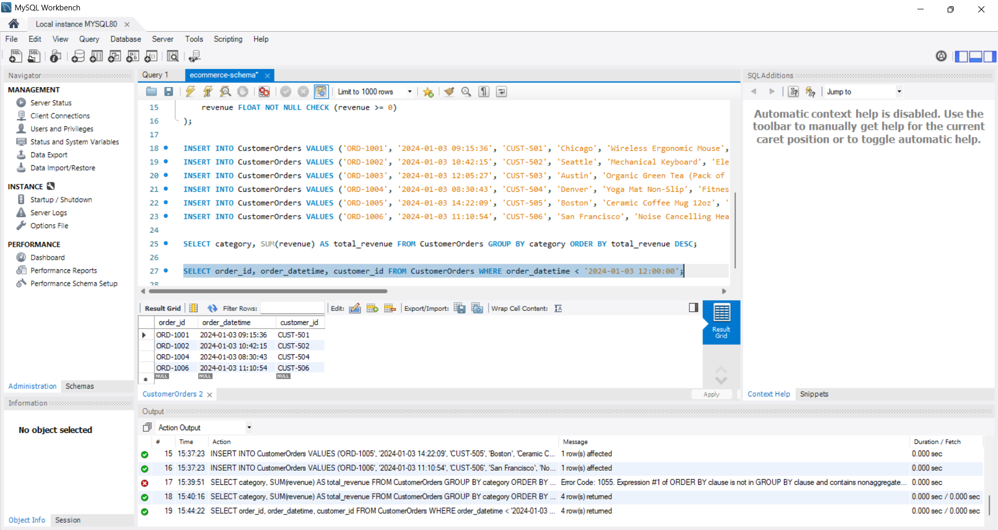
- Applying Filter
Identify orders whose payment is made only through Credit Card.

SELECT order_id, customer_id, product_name, category, quantity FROM CustomerOrders WHERE payment_method = 'Credit Card';

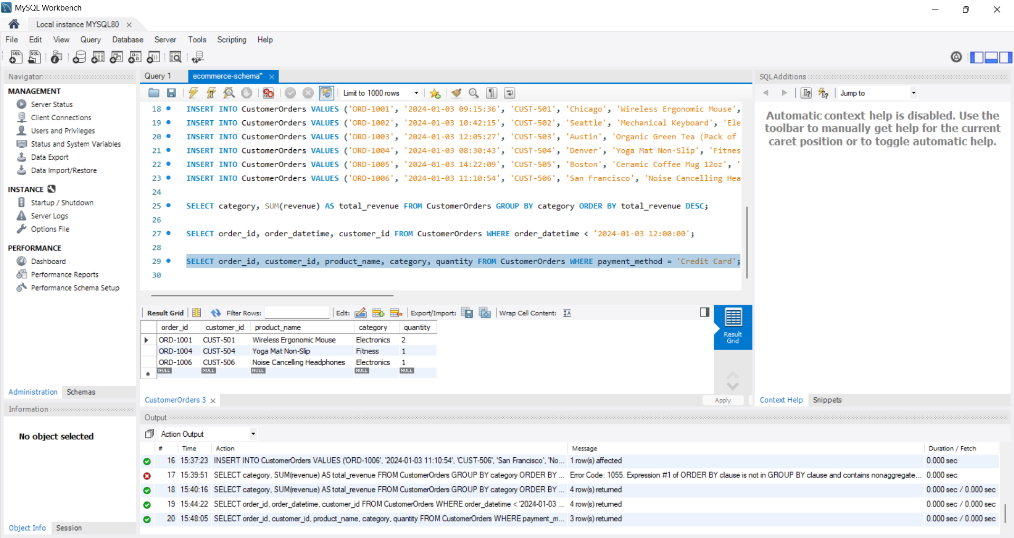

- Grouping, average and identifying top 2 categories
Find top 2 product categories with highest average revenue.

SELECT category, AVG(revenue) as average_revenue FROM CustomerOrders GROUP BY category ORDER BY average_revenue DESC LIMIT 2;

